**Name – Parag Gattani**

Program No. – 03

Program Title – LED fading without potentiometer

**AIM**

Demonstrate to show LED fading.

**HARDWARES REQUIRED**

* Arduino Board
* LED bulb

**CIRCUIT DIAGRAM**

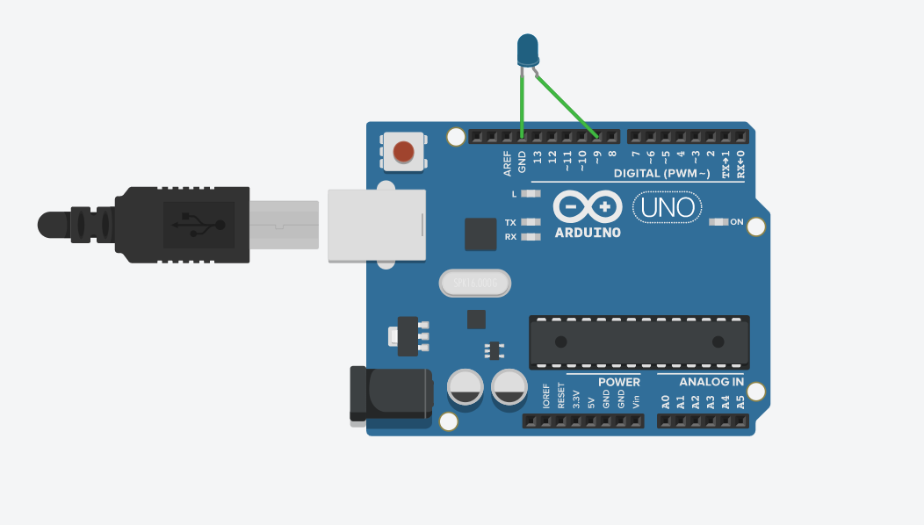

**WRITE-UP**

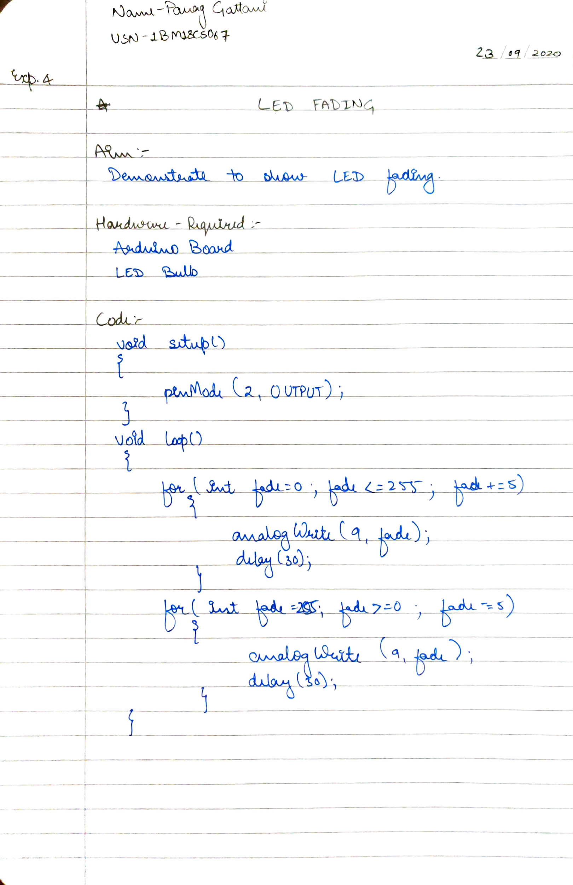

**CODE**

void setup()

{

pinMode(2, OUTPUT);

}

void loop()

{

for(int fade =0;fade <=255; fade+=5)

{

analogWrite(9,fade);

delay(30);

}

for(int fade = 255; fade>=0;fade-=5)

{

analogWrite(9, fade);

delay(30);

}

}

**OUTPUT**

Fading of LED.